PatchNotes

**Team 3:**

**Team Members:** Gavin Landry, JJ Whitehurst, Diego

**Summary:**

Amid the challenges posed by the constant changes in federal and local government, the team has struggled to stay informed and well-educated on significant local and national legislation. To remedy this, we plan to implement a web app called “PatchNotes”. We imagine PatchNotes as a user-friendly platform that simplifies the process of staying informed about government regulations and legislative updates. PatchNotes will provide concise, digestible summaries of new laws, amendments, and policies at both federal and local levels. Users will have the ability to personalize their experience by selecting areas of interest—such as healthcare, education, technology, or climate change—and receive curated updates tailored to their preferences.

The app will feature key functionalities such as real-time alerts for newly enacted legislation, a searchable archive of past updates, and visual summaries to help users quickly grasp the key points. Its a top priority to keep authenticity, PatchNotes will link to official documents and forums for users to discuss the implications of specific policies.

**User & Stakeholder Key Points**

* PatchNotes is a US government only app, including foreign policy.
* Target user base values quality of information and convenience factor.

**Personas**

**John Doe:** John is a busy individual who values maintaining an informed opinion on current events within the U.S government. He is aware of the heavy bias found in mainstream news outlets and finds it tiresome to review 5+ publications for his news. Instead, he wishes there was a real-time service for him to view current legislation and news within the government, filtering out the bias and going right to the source - the US government’s websites.

**Jane Doe:** Jane is a law professional working in criminal law. She has been looking for a good news source based off real, current information coming straight from official sources of the US government. She values unbiased, factual sources describing real motions and legislation and is tired of having her time wasted by social media news, grifters, outright false news, and clickbait. Therefore she chooses Patchnotes.

**Elon Musk:** As a newly mega-important figure within the government, Elon Musk wants a way to keep up to date with governmental happenings so he installs Patchnotes after hearing about it online. With a packed schedule, Mr. Musk finds it convenient that he has an information stream of government news on one service.

**Technologies**

* nodejs backend
* html and js frontend
* react? also frontend
* mongo (make request for new data periodically, put in database, call database instead of api call every subsequent time)

**Functional and Non-functional Requirements**

There are many functional requirements that are necessary for the core functionality of our app. Users should be able to register and login with an email and password, so they can save news articles that interest them. We need to pull news data from U.S. government official sources to display on our site, as that is its main purpose. Users will be able to search and filter through our data to find what they are looking for.

There are also non-functional requirements present that will make our application scalable, more efficient and user friendly. The first is automatic data collection and updates to the site, so users have the most up to date information, and we do not have to manually update every time an event happens. The second is monitoring our sources to ensure accuracy and relevancy for users as well as database cleanliness for us. Lastly we will implement mobile responsiveness so the site is accessible to more users.

**Project Schedule**

Sprint 0.5 will take place through the rest of January. In this time, we will fully develop our plans and ideas until we have an agreed upon vision of what the project will be. We will start creating the project backlog, and finish any remaining setup. (vm stuff, repo access, other organizational tools) Sprint 1 will take place in February / until midterm presentation. In this sprint, we will focus on our data collection and storage. We will have data displayed with a minimal frontend . Sprint 2 will take place in March. We will implement the filtering and search features as well as the saving feature. Sprint three will take place in April and will continue until presentation day. By this time, we will only have minor features and finishing touches / bug fixes left. We will finish the frontend and prepare for the presentation.

**Site Map**

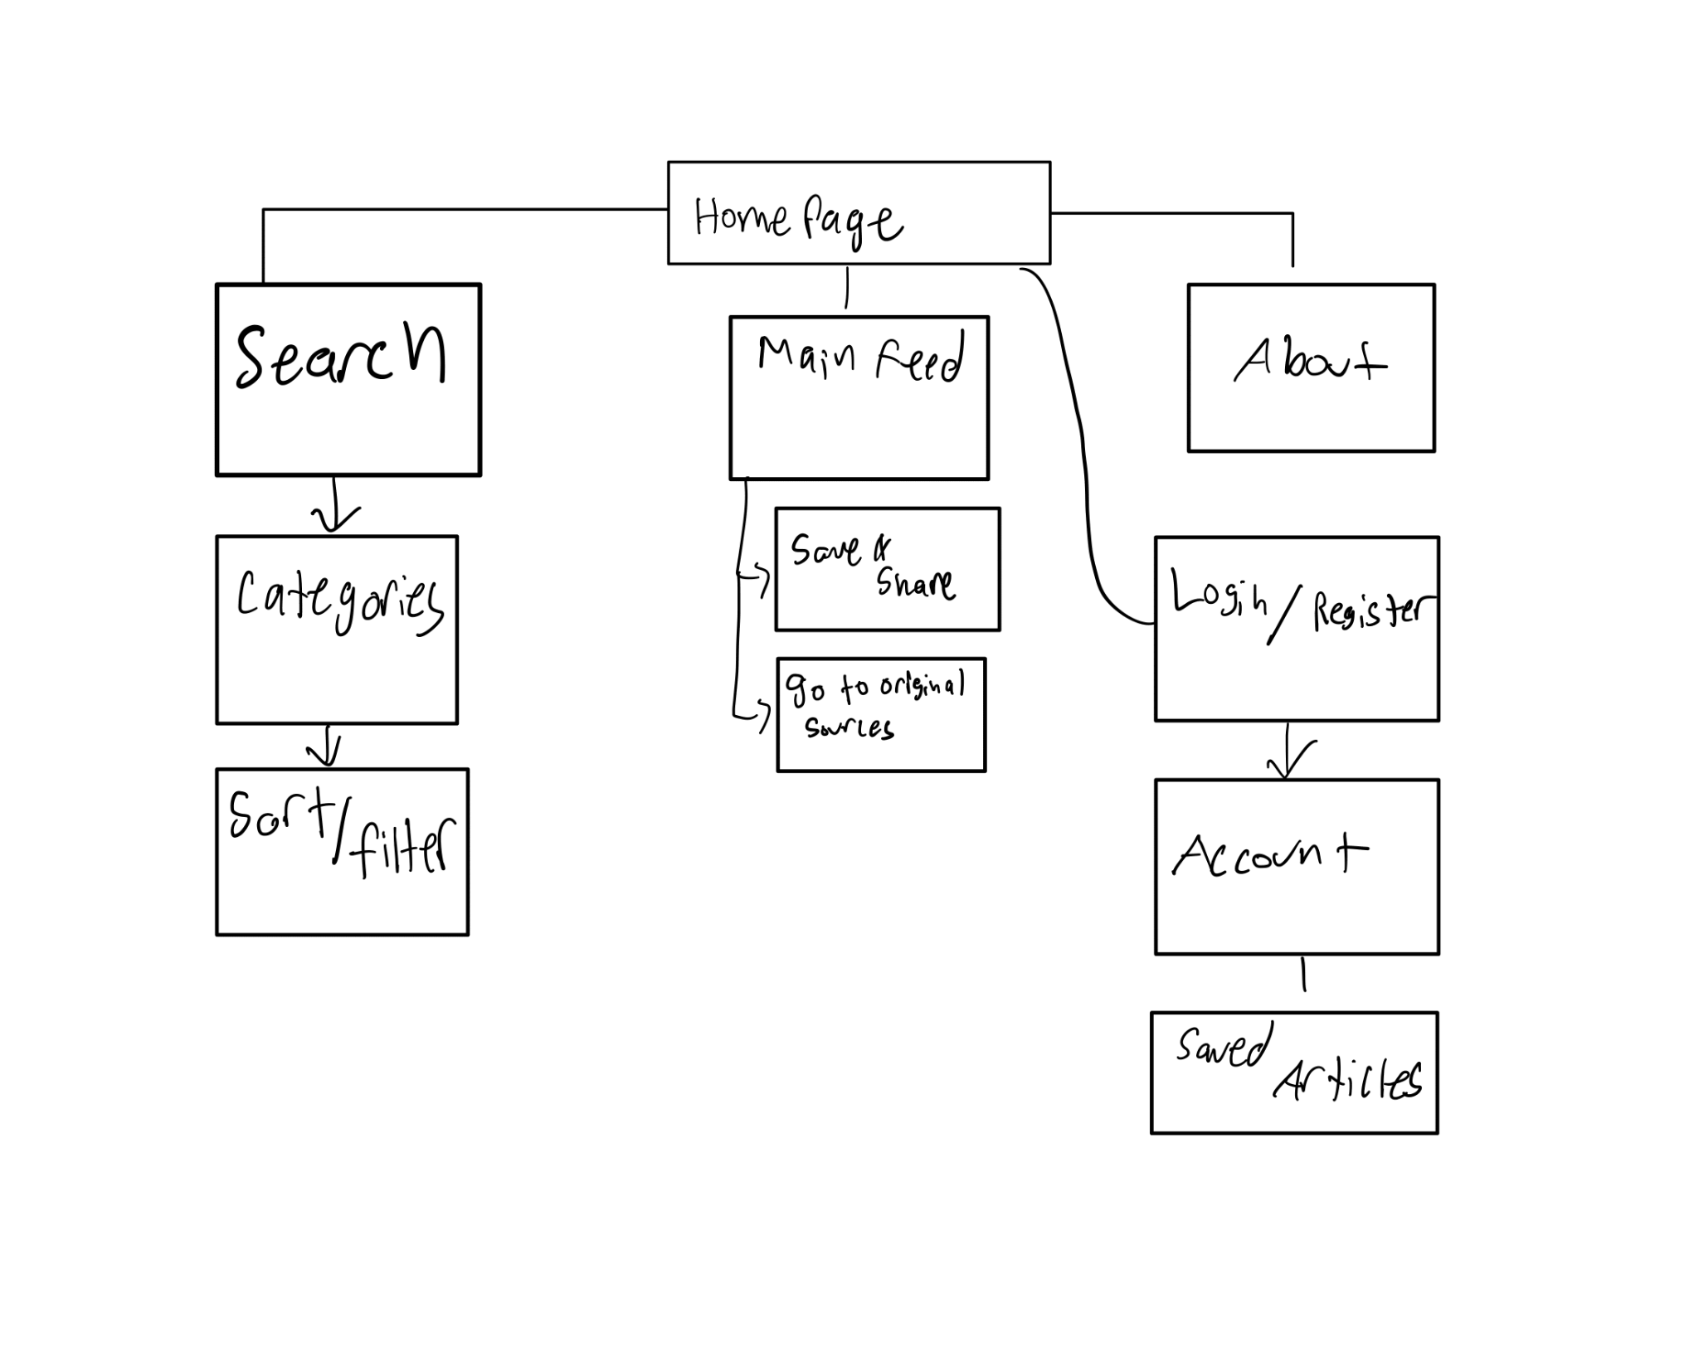

**Wireframes**

